**HW 5 - Cell2Cell**

1. **Rakshit Mathur RXM210132**
2. **Anu Challa AXX220008**
3. **Dong Thanh Duong DTD170000**
4. **Satya Sai Manoj Pithani SXP220184**
5. **Vishnu Mani Deep Ala**

1. ***Run a Logistic Regression Predictive Model***

**a)**

a. There are a total of 69626 customers in the data.

b. Count in calibration set is 39186 and in validation set is 30440.

c. The Churn Rate in Calibration Set is 0.5.

d. The Churn Rate in Validation Set is 0.0195.

**b)**

Please refer to the R code file.

**c)**

Please refer to the R code file.

Snippet of running Logistic Regression on Calibration set:

Snippet of Odds Ratios:

Interpretation of the Odds Ratios:

The largest odds ratio is for retcall (OR=2.29). This indicates that if a customer calls the retention team, the odds of churn increase by 2.29 times. The p-value is < 0.001 indicating this is a statistically significant positive relationship.

The next largest is for refurb (OR=1.26). This means that if a user is using a refurbished handset, the odds of churn increase by 1.26 times. The p-value is < 0.001, so it is a significant positive relationship.

The smallest odds ratio is for creditaa (OR=0.698). This shows that if a user has a high rating ‘AA’, the odds of churn decrease by a factor of 0.698. The p-value is < 0.001 showing a significant negative relationship.

The next smallest is for activesubs (OR=0.812). The greater number of active subscriptions a user has, the odds of churn decrease by a factor of 0.812. The p-value is < 0.001 showing a significant negative relationship.

**d)**

Predicting Attrition probabilities on Validation Set:

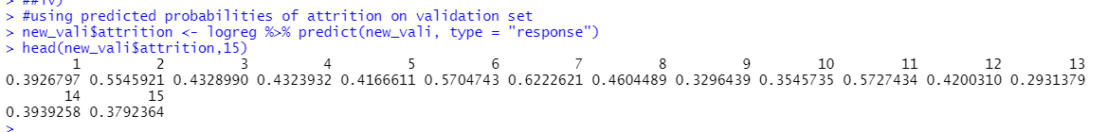

Five highest Attrition probabilities:

***2. Determine and Rank the Economic Importance of the Predictor Variables***

**a)  Produce a data frame (i.e., data matrix) with odds ratios and p-values as 2 columns.**

**a. First, convert parameter coefficients from the earlier logistic regression to odds ratios and**

**save them in a variable (let's say 'OR').**

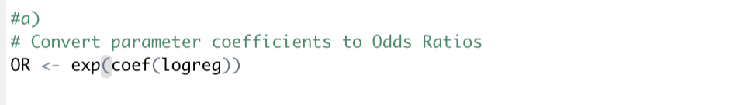

1. **You can extract p-values with the following command. Note that there is no end bracket.**

coef(summary(churnmodel))[,'Pr(>|z|)']

Save them in a variable (let's say 'pvalues').

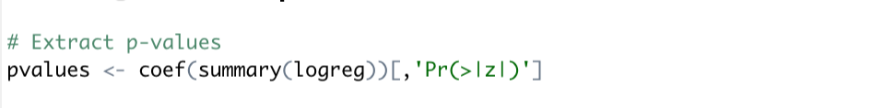

1. 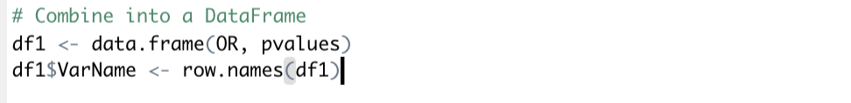**Combine OR and pvalues into a data frame called df1 using data.frame command.**

1. **View this data frame to make sure that it looks as expected.**



OUTPUT:

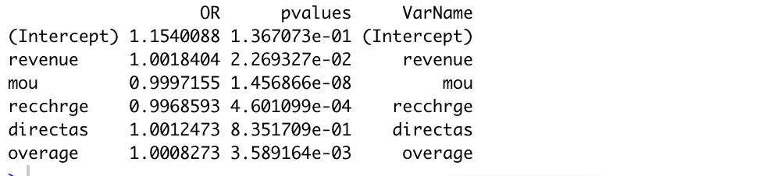

**b)  Calculate standard deviations of the variables in the calibration data (e.g., you can use sapply() function) and save them as a data frame**

**a + b. Using the function (x) and na.rm = TRUE options to calculate the standard deviations based on non-missing value:**

**c. Saved data as “df2” using data.frame**

**c)**

a. Added a column of row names to both df1 and df2

b. Merge df1 and df2 based on matching VarNam



d**)  Round the numeric columns of the merge data frame to 5 decimal points using round() command and keep rows with p-values < 0.05 only.**

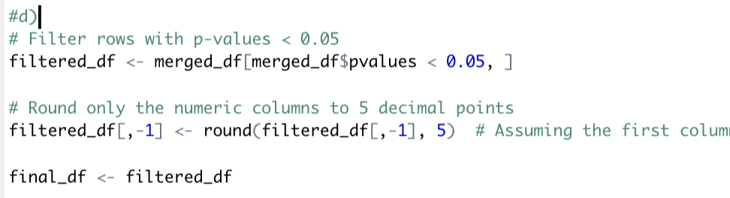

**e)  Export the results into a CSV file using write.csv() command.**

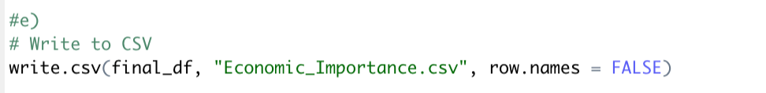

**f)  Open the CSV file in Excel and determine the economic importance of each variable for predicting attrition (see lecture slides for the formula). Note the difference between a dummy variable and a non-dummy variable in the formula. See variable descriptions in the spreadsheet "Cell2Cell Data Documentation.xls". Be careful with variables that have similar names.**

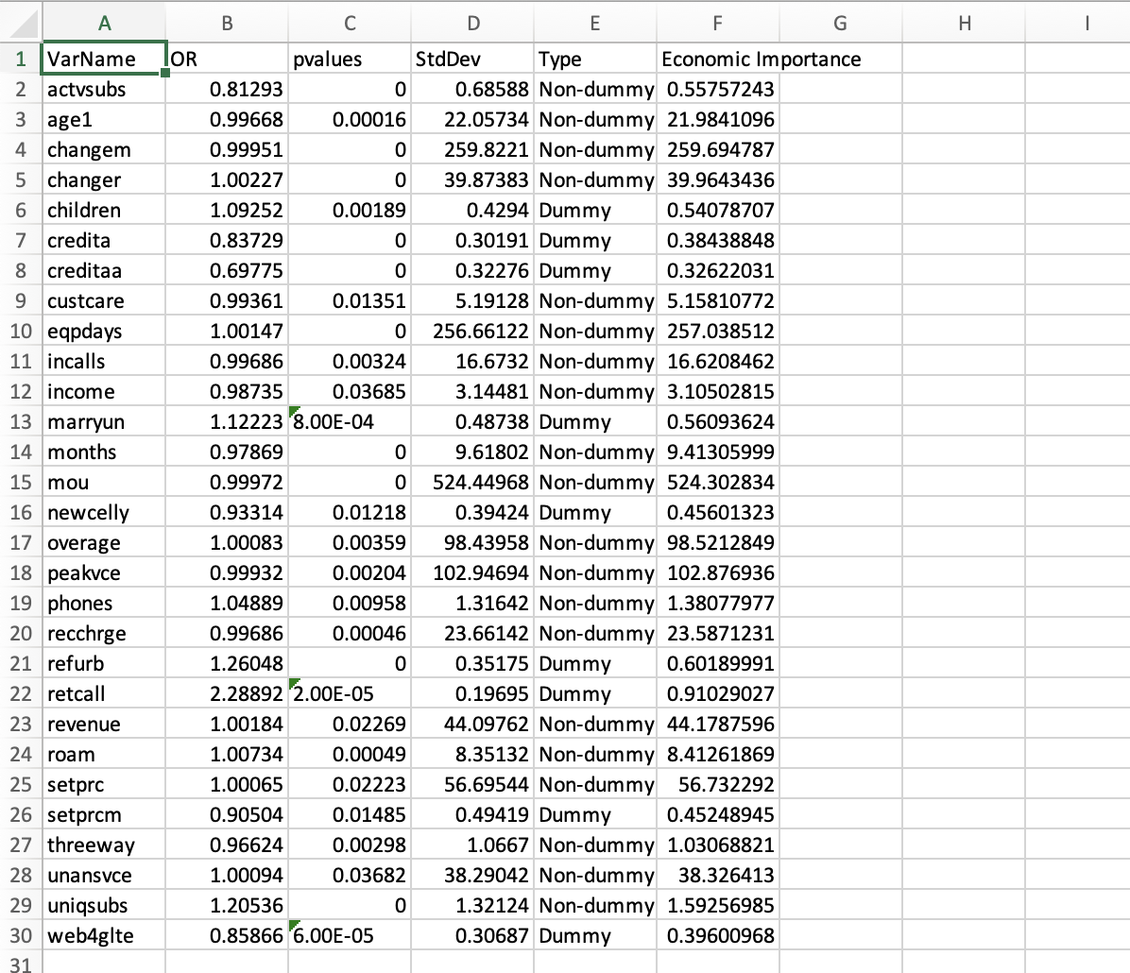

***3. Create a Contingency Based Incentive Plan***

**a)  Looking at the top 7 importance-ranked list of predictor variables, decide which of them suggests a retention action by Cell2Cell (i.e., actionable at the retention department).**

Based on the top 7 importance-ranked predictor variables for Cell2Cell's retention strategy, we can identify which are actionable by the retention department:

mou (Mean monthly minutes of use):

Actionable: Potentially, but indirectly.

Reason: While the direct control of usage minutes is not feasible, retention strategies can focus on incentivizing higher usage through better plans or rewards.

changem (% Change in minutes of use):

Actionable: Yes.

Reason: This variable directly relates to changes in customer behavior, which can be influenced through flexible plans or special offers to accommodate changing usage patterns.

eqpdays (Number of days of the current equipment):

Actionable: Yes.

Reason: This is directly related to equipment age, and the retention department can offer upgrades or discounts on new devices to encourage contract renewals.

peakvce (Mean number of in and out peak voice calls):

Actionable: Indirectly.

Reason: Though the department can't directly influence call times, it can offer plans that provide better rates or incentives for calls made during peak hours.

overage (Mean overage minutes of use):

Actionable: Yes.

Reason: The retention department can offer plans with higher usage limits or bonuses for low overage to prevent customer churn due to overage fees.

setprc (Handset price):

Actionable: Yes.

Reason: Handset pricing is a significant factor in customer retention, where offering discounts or special deals on handsets can be an effective retention strategy.

revenue (Mean monthly revenue):

Actionable: Indirectly.

Reason: While directly influencing revenue is challenging, retention actions can focus on up-selling or cross-selling to increase revenue or offering value-added services.

**b)  For each actionable and statistically significant predictor variable, specify what retention action you suggest, i.e., what type of incentive you plan to give consumers to encourage them to remain with Cell2Cell (e.g., new phone, rebate, new plan). You do not need to provide the costs of the incentives. Just make sure that your incentives are reasonable and in accordance with "actionable" predictor variable.**

For each actionable and statistically significant predictor variable, here are the suggested retention actions and incentives that Cell2Cell could offer to encourage customer retention:

changem (% Change in minutes of use):

Suggested Action: Offer tailored plans that adapt to changing usage patterns. For customers reducing their usage, provide lower-cost plans to prevent them from switching to more economical competitors. For those increasing usage, offer bonus minutes or upgraded plans at discounted rates.

eqpdays (Number of days of the current equipment):

Suggested Action: Implement a loyalty program that offers discounts on new handsets or attractive trade-in options for old devices. This could be particularly effective for customers with older handsets, encouraging them to renew their contract in exchange for a new, subsidized device.

overage (Mean overage minutes of use):

Suggested Action: For customers frequently incurring overage charges, offer customized plans with higher usage limits or rollover minutes. Additionally, providing occasional overage fee waivers as a goodwill gesture can enhance customer loyalty.

setprc (Handset price):

Suggested Action: Provide special discounts on handsets, particularly for high-value or long-term customers. Bundling handsets with specific plans or offering installment payment options at low interest rates can also be attractive.

revenue (Mean monthly revenue):

Suggested Action: For high-revenue customers, exclusive VIP services or premium support can be offered. Incentives like bonus data, special discounts on family plans, or access to exclusive content can also be used to retain these valuable customers.

**c)  For each non-actionable and statistically significant predictor variable, specify how to use the intelligence obtained (e.g., share the information with other departments, and if so, which department).**

For the non-actionable and statistically significant predictor variables, here's how Cell2Cell can utilize the intelligence obtained:

mou (Mean monthly minutes of use):

Use of Intelligence: This information could be shared with the marketing and product development teams. Understanding usage patterns can help in designing targeted marketing campaigns and developing new features or services that cater to high-usage customers.

peakvce (Mean number of in and out peak voice calls):

Use of Intelligence: This data can be valuable for network operations and planning departments. Insights into peak call times can aid in optimizing network capacity and performance, ensuring high service quality during peak usage periods.

By sharing such insights with relevant departments, Cell2Cell can enhance its service offerings, marketing strategies, and overall customer experience, indirectly contributing to customer retention and satisfaction.